**Model learning with logistic regression**

1. Create structure like this via using sub panel in diagram

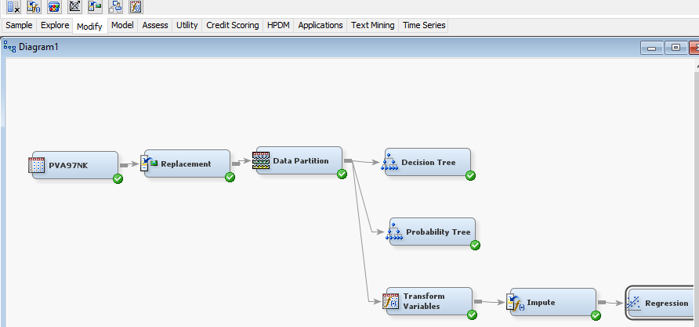

Pic1.

Decision tree and probability tree is the same.

In regression need to set type of regression. Type is logistic regression.

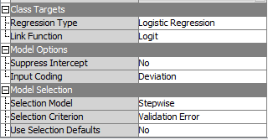

Pic2.

As we can see also we need to use stepwise and validation error.

If we run our regression and open results, we`ll see in view > model > iteration plot this one

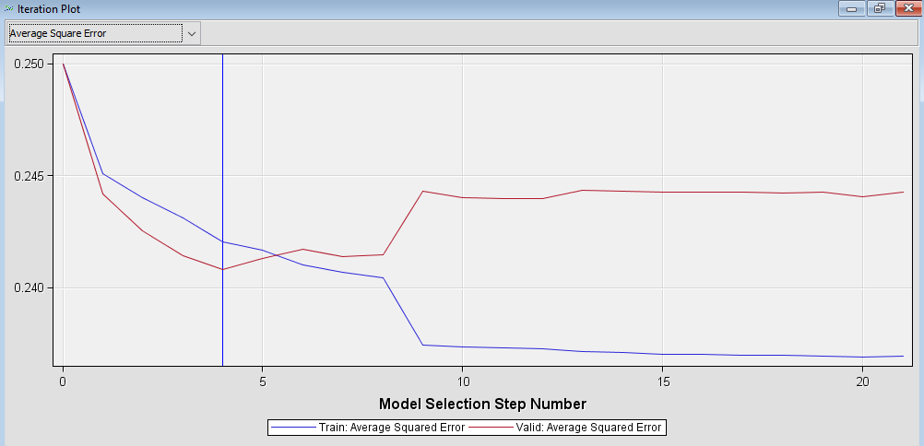

Pic3.

In the start our result was 12 step, coz we didn’t use transform variables and impute.

Transform values: some values have zero values or not symmetric graphs, so we need to use log functions on it.

Impute: change miss values.

So after this two blocks we can teach our model for 3 or 4 fields instead 12-20 if we use validation error or misclassification (pic2)

More explanations in zip file with some guide-photos.

So, if we want to teach our model with less variables, we need to research where we have miss values or which values we need to change function. After see it on graph where valid less than train and relearn our model.